To: | Cabinet
Date: | 09 December 2020
Report of: | Head of Financial Services
Title of Report: | Treasury Management Mid-Year Review for April – September 2020

Summary and recommendations
Purpose of report: |  | To report on the performance of the Treasury Management function for the 6 months to 30 September 2020
Key decision: |  | No
Executive Board Member: |  | Councillor Ed Turner, (Deputy Leader) Finance and Corporate Assets
Corporate Priority: |  | All
Policy Framework: |  | Treasury Management Strategy
Recommendations: That Cabinet resolves to:
1. | Note the performance of the Treasury Management function for the six months to 30th September 2020

Appendices
Appendix 1 | List of investments as at 30th September 2020
Appendix 2 | Risk Register

Introduction and Background
- This report has been written in accordance with the requirements of the Chartered Institute of Public Finance and Accountancy’s (CIPFA) Code of Practice on Treasury and has been prepared in compliance with CIPFA’s Code of Practice on Treasury Management, covering the following:
- An economic overview for the first part of the 2020/21 financial year
- A review of the Council’s investment portfolio for 2020/21
- A review of the Council’s borrowing strategy for 2020/21
- A statement of compliance with Treasury and Prudential Limits for 2020/21
- The Council operates a balanced budget, which broadly means cash raised during the year will meet its cash expenditure. Part of the treasury management operations ensure this cash flow is adequately planned, with surplus monies being invested in suitable counterparties, providing adequate liquidity and security initially before considering optimising investment return.
- The second main function of the treasury management service is the funding of the Council’s capital plans. These capital plans provide a guide to the borrowing need of the Council, essentially the longer term cash flow planning to ensure the Council can meet its capital spending operations. This management of longer term cash may involve arranging long or short term loans, or using longer term cash flow surpluses, and on occasion any debt previously drawn may be restructured to meet Council risk or cost objectives.
Economic Overview
- On 19th March 2020 the Bank of England cut the base rate to 0.10% to help control the economic shock of the Coronavirus. The rate looks likely to stay at this level until inflation is sustainably meeting the Bank of England’s target levels.
- Bank of England has squashed any idea of using negative interest rates, at least in the next six months or so. It suggested that while negative rates can work in some circumstances, it would be “less effective as a tool to stimulate the economy” at this time when banks are worried about future loan losses. It also has “other instruments available”, including Quantitative Easing (QE) and the use of forward guidance.
- The pace of recovery is not expected to be in the form of a rapid V shape, but a more elongated and prolonged one after a sharp recovery in June through to August which left the economy 11.7% smaller than in February. The last three months of 2020 are now likely to show no growth as consumers will probably remain cautious in spending and uncertainty over the outcome of the UK/EU trade negotiations concluding at the end of the year will also be a headwind. If the Bank felt it did need to provide further support to recovery, then it is likely that the tool of choice would be more QE.

Interest and Interest Rate Forecasts

- The Council’s treasury advisor, Link Group, provided the following forecasts (PWLB rates are certainty rates, gilt yields plus 180bps):

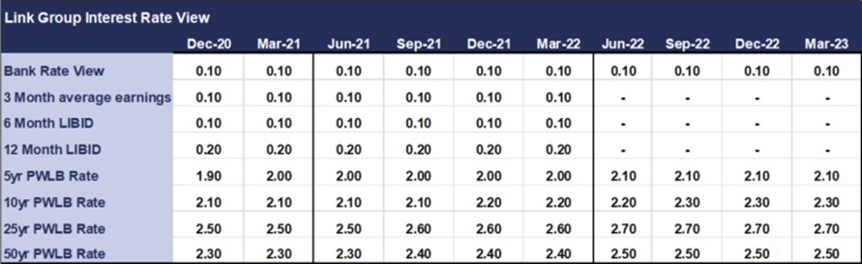

- The coronavirus outbreak has done huge economic damage to the UK and economies around the world. After the Bank of England took emergency action in March to cut Bank Rate from 0.75% to 0.25% on 11th March 2020 and then subsequently to 0.10% on 19th March 2020, it left the Bank Rate unchanged at its meeting on 6th August and subsequently 16th September. It also indicated that there would not be any use of negative interest rates in, at least, the next six months while the Bank carries out research work with high street banks on the potential impact on them of negative rates. It suggested that while negative rates can work in some circumstances, it would be “less effective as a tool to stimulate the economy” at this time when banks are worried about future loan losses. It also stated that it has “other instruments available”, including QE and the use of forward guidance. As shown in the forecast table above, no increase in Bank Rate is expected within the forecast horizon ending on 31st March 2023 as economic recovery is expected to be only gradual and, therefore, prolonged.
- From the local authority borrowing perspective, HM Treasury imposed two changes of margins over gilt yields for PWLB rates in 2019-20 without any prior warning. The first took place on 9th October 2019, adding an additional 1% margin over gilts to all Public Works Loans Board (PWLB) period rates. That increase was then at least partially reversed for some forms of borrowing on 11th March 2020, but not for mainstream General Fund capital schemes, at the same time as the Government announced in the Budget a programme of increased infrastructure expenditure. It also announced that there would be a consultation with local authorities on possibly further amending these margins; this was to end on 4th June, but that date was subsequently put back to 31st July 2020. It seems clear that HM Treasury will no longer allow local authorities to borrow money from the PWLB to purchase commercial property if the aim is solely to generate an income stream (assets for yield).
- Following the changes on 11th March 2020 in margins over gilt yields, the current situation is as follows: -
- PWLB Standard Rate is gilt plus 200 basis points (G+200bps)
- PWLB Certainty Rate is gilt plus 180 basis points (G+180bps)
- PWLB HRA Standard Rate is gilt plus 100 basis points (G+100bps)
- PWLB HRA Certainty Rate is gilt plus 80bps (G+80bps)
- Local Infrastructure Rate is gilt plus 60bps (G+60bps)
It is possible that the non-HRA Certainty Rate will be subject to revision downwards after the conclusion of the PWLB consultation; however, the timing of such a change is currently an unknown, although it would be likely to be within the current financial year.
- As the interest forecast table for PWLB certainty rates, (gilts plus 180bps), above shows, there is likely to be little upward movement in PWLB rates over the next two years as it will take economies, including the UK, a prolonged period to recover all the momentum they have lost in the sharp recession caused during the coronavirus shut down period. Inflation is also likely to be very low during this period and could even turn negative in some major western economies during 2020/21. ,

Investment Portfolio and Performance
- The budgeted investment income for 2020/21 is £1.223 million. As at the 30th September 2020, forecast investment income for 2020/21 is £1.044m. Many of the Council’s current investments were placed at higher levels of interest before the Base rate was reduced in March 2020, the Council has also taken advantage of better rates where possible
- The Treasury Management Strategy for 2020/21 was approved by this Council in February 2020; to date the Strategy has been fully adhered to.
- As part of its Strategy, the Council aims to maintain a diversified investment portfolio whilst ensuring there are no policy and procedure breaches. Security of investments is always the primary concern when arranging investments with liquidity and yield being secondary, but key considerations.
- The Council operates an approved counterparty listing which details all institutions with whom the Council may invest, the maximum amount which may be invested with any single counterparty group at any given point and the maximum duration period. The counterparty list is set in association with recommendations from Link Asset Services although ultimate authorisation of approved counterparties rests with the Section 151 Officer. The list is actively managed and reviewed on a weekly basis or more regularly if required.
- Monthly monitoring meetings are held with the Section 151 Officer, Financial Accounting Manager and Treasury staff to discuss investments in terms of counterparties and maturity dates, cash flow, interest and borrowing rates and Treasury operational and Strategic strategies.
- The strategy also adopts an ethical approach to investments, stating that:
“The Council will not knowingly invest directly in businesses whose activities and practices pose a risk of serious harm to individuals or groups, or whose activities are inconsistent with the Council’s mission and values. This would include, inter alia, avoiding direct investment in institutions with material links to:
- Human rights abuse (e.g. child labour, political oppression)
- Environmentally harmful activities (e.g. pollutants, destruction of habitat, fossil fuels)
- Socially harmful activities (e.g. tobacco, gambling)”
- The Council has been able to take advantage of some further green deposit notice accounts offered by Barclays Bank who are working in association with Sustainanalytics, a leading global provider of environmental, social and corporate governance research and ratings, to achieve a positive environmental impact. Their green framework covers the following environmental areas:
- Energy efficiency projects and renewable energy
- Sustainable food agriculture and forestry
- Waste management
- Greenhouse gas emission reduction
- Sustainable water
- The Council currently has £7.5 million in these accounts.

Pooled Investment Funds
- At present, the Council has placed investments with two property funds; CCLA Investment Management, which is a property fund that limits its investors to Charities, Churches and Local Authorities and Lothbury Investment Management, a specialist UK property fund manager with a range of funds providing high quality exposure to different property sectors. Due to the Covid-19 pandemic, property prices have a lot of uncertainty about them and capital values have fallen. However, both our respective fund managers have reassured us that their investments are well placed to recover and over the longer term capital values will pick up. In the short term Dividends are still being paid at similar levels to pre-Covid times and are still giving us a good return on our investments. Both property funds have reduced their retail holdings which de-risks the capital value they hold.
CCLA Investment Management Limited
- The Council has held a £3m investment in the CCLA fund since September 2013. The investment has produced quarterly returns ranging between 5% and 6% and it is expected that the Fund will continue to achieve rates in this region.
- Additionally, the value of the Council’s investment with CCLA has appreciated from £3m to £3.6m as at 30th September 2020, equating to growth of 20.33% to date from inception. However, the values of the individual unit prices have fluctuated over time and the effect of capital appreciation (and depreciation) is illustrated in the graph below. There has been pressure on the overall property value but the dividend is being maintained and prices are always going to fluctuate over time. This is seen as a long term investment.

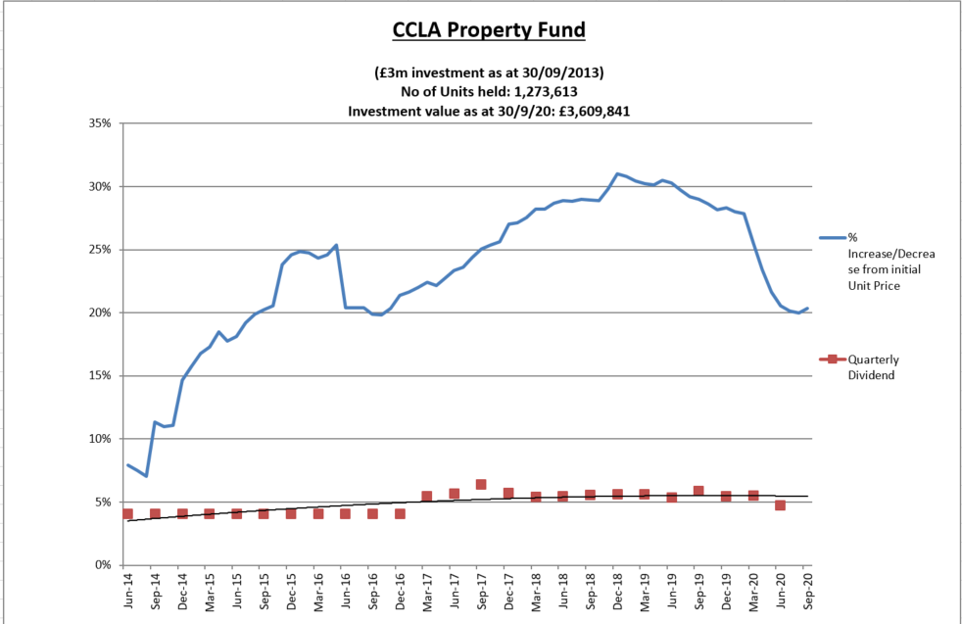

- Changes to the accounting rules on property funds means that the principal gain or loss will now be charged to the Surplus or Deficit on the Provision of Services, within the Councils Income and Expenditure Account, rather than being held on the balance sheet. However, following consultation by MHCLG the government has introduced a mandatory statutory override for local authorities to reverse out the effect for five years from 1st April 2018 after which surpluses as well as deficit will impact on the Councils revenue position. Even without the statutory override, the Council would have created a reserve to hold the funds until the return was realised due to the potential for fluctuations in the property markets.
- The investment returns around £40k per quarter.
Lothbury Investment Management
- During 2014/15, the Council invested £7m in the Lothbury Property fund and the Fund has produced quarterly returns in the range of 3-4%. Furthermore, the Fund has seen a capital appreciation over the period with the value currently standing at £7.916m, compared with £7m at inception, equating to overall growth of 13.08% to date. However, as with CCLA, the values of the individual unit prices have fluctuated over time and the effect of capital appreciation (and depreciation) is illustrated in the graph below. The changes to accounting rules will also affect the Lothbury Property Fund as explained in paragraph 21 above.

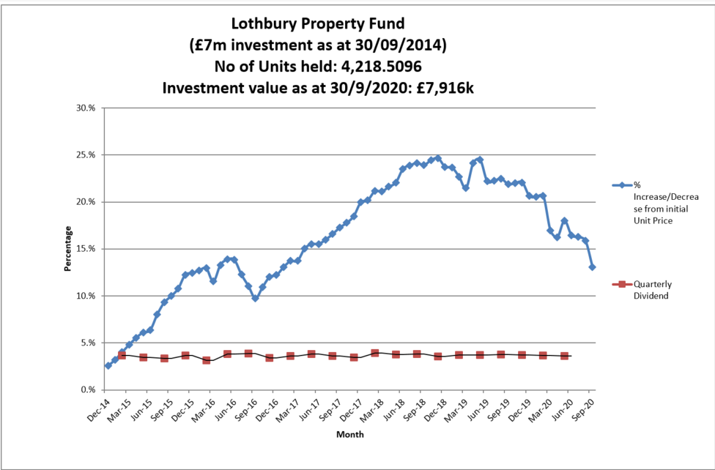

The investment returns around £60k per quarter.
Multi-Asset Fund(s)
- As agreed in the Treasury Strategy for 2020/21, and included in the budget report for 2020/21, the Council is selecting a multi-asset fund or funds to invest an amount of £10m. The selection process was paused due to the pandemic but has recently been recommenced. The process is nearing conclusion and Council Officers will then liaise with the fund managers regarding the optimum investment point.
Investment Portfolio
- As at 30th September 2020, the Council’s total investment portfolio amounted to £103.4m, with £10m of this being held in property funds and £32.9m being held in instant access cash facilities with the balance being held in banks and building societies
- The graphs below illustrate how the Council’s investment portfolio is distributed, both in terms of the type of investment and counterparty category:
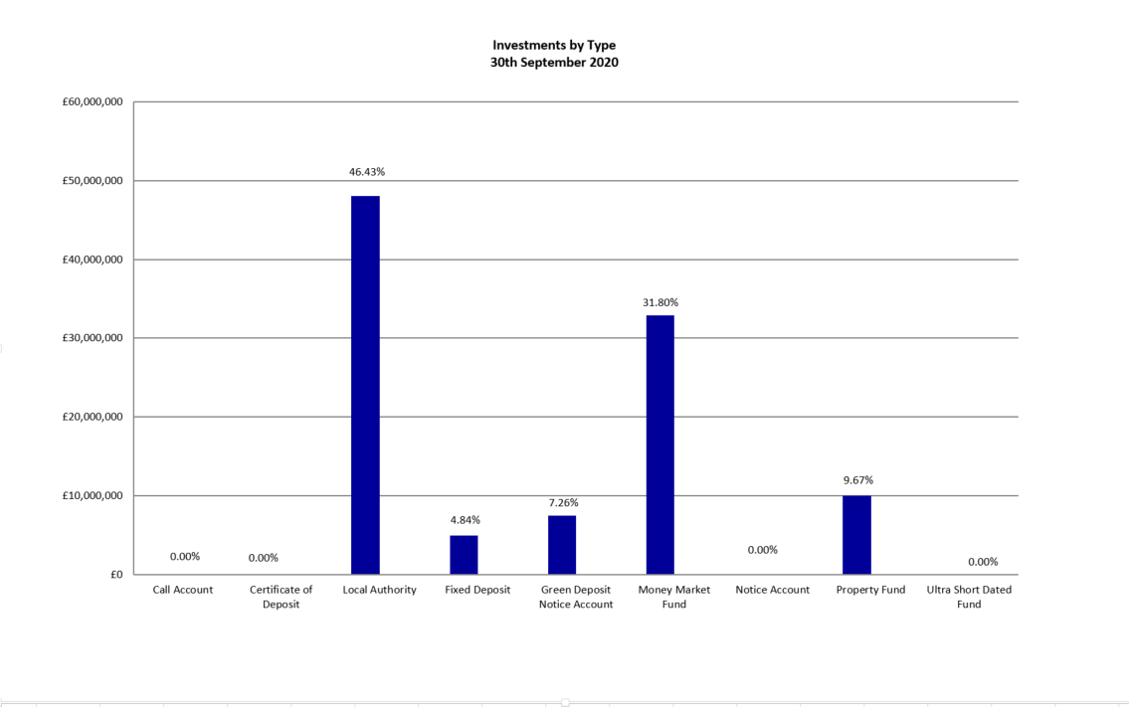
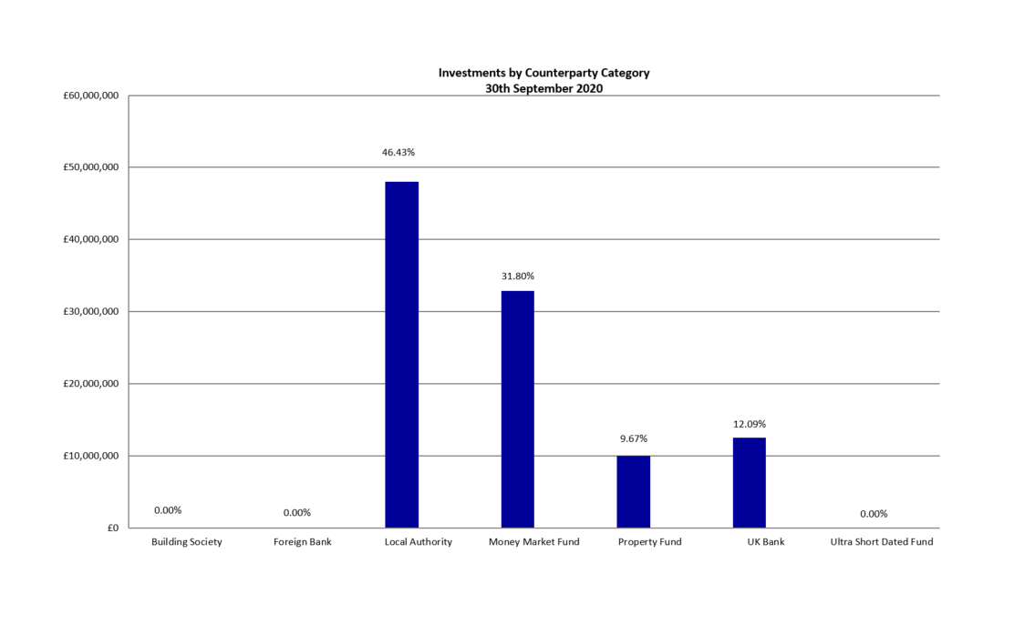
- Fixed deposits and certificates of deposits both have an agreed start and end date which are arranged where possible, to suit the cashflow requirements. However, as mentioned previously, it is also important to keep a proportion in instant access funds.
- The Council’s Treasury Management Strategy limits non-specified investments to 25% (or £25m whichever is greater) of the previous year’s average investment portfolio. This limit is reviewed each year when setting the Strategy in order to ensure a balanced and diversified portfolio of investments. Property funds and investments in excess of 364 days are classified as non-specified due to the associated risk; property funds by nature are high risk due to the volatility of the market. There are several factors that deem longer term investments to be more risky in nature including the risk of interest rate rises and the commitment of cash for longer periods.
- £10 million is committed in the CCLA and Lothbury property funds and the Council is currently looking at utilising residual headroom to invest further in some non-specified investments. It should be noted that the £5 million invested in the National Homelessness Property Fund (Real Lettings) is, following discussions with the Council’s external auditors, classified as a service investment undertaken using service delivery powers rather than treasury powers under Section 12 of the Local Government Act 2003. This means the counterparty limit for the £5m invested in the National Homelessness Property Fund is not taken into account when assessing the residual headroom available for investment in non-specified investments.
- The Strategy defines a specified investment as one that is in sterling, no more than one year in duration or, if in excess of one year can be repaid earlier on request and with counterparties that meet the Council’s credit rating criteria. Additionally, once the duration of a non-specified investment falls below 366 days, it also falls into the Specified category. The maturity profile for the Council’s specified investments (equating to £60.5m when excluding the instant access cash) is illustrated below.

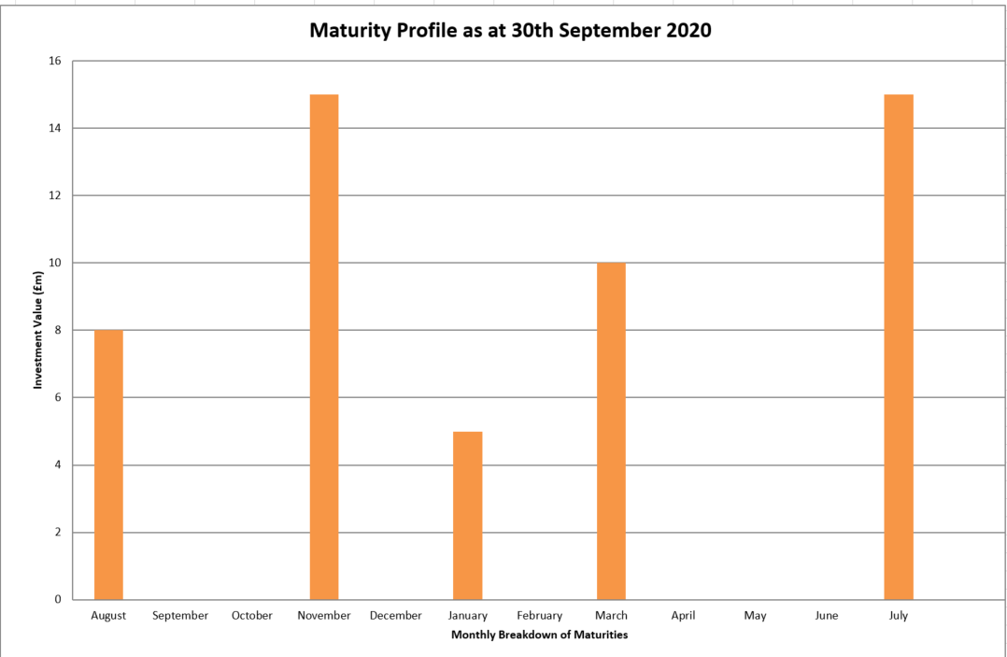
- The graph below illustrates the same investments by duration period in order to demonstrate duration periods. It is not surprising that the majority of investments have a duration period of six months as this is the limit for most of the banks and building societies with whom the Council may invest. When the opportunity arises, longer investments are arranged to allow for a greater yield.

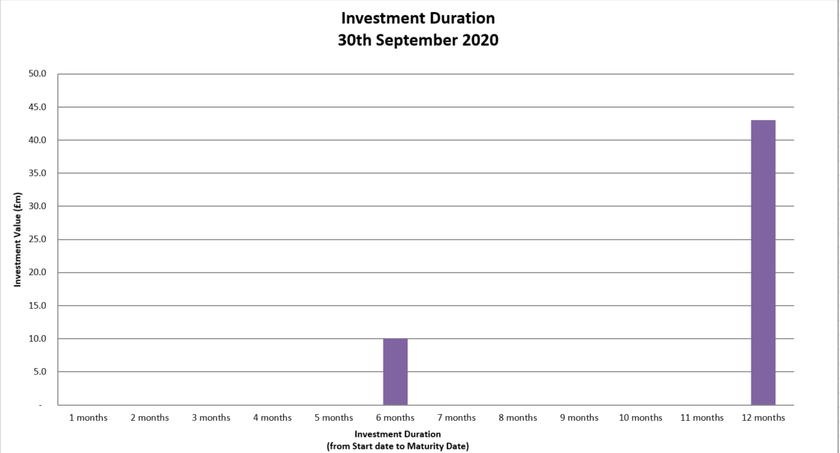
Borrowing
- The Council has not taken on any additional debt during the year to date and so the balance of its external borrowing remains at approximately £198.5 million; this figure relates to funds borrowed from the PWLB to buy out the Housing Revenue Account (HRA) from the subsidy system and relates wholly to Housing with interest repayment being met by the HRA. The Council does not consider that debt restructuring and/or premature repayment would be practical at this time as due to the differential in interest rates, the Council would incur a large premium from the PWLB for doing so. The Council continues to monitor borrowing interest rates and forecasts on a regular basis and will continue to review its position on debt restructuring.
- The Council anticipates borrowing in the future to meet its capital expenditure requirements, including loans to the Housing Company, but does not anticipate any external borrowing during 2020/21.
Treasury and Prudential Limits for 2020/21
- The Council has operated all of its Treasury Management activity within the parameters set by the Treasury and Prudential indicators in the Treasury Management Strategy for 2020/21.
Other Key Updates
Changes in Risk Appetite
- The 2018 CIPFA Codes and guidance notes have placed enhanced importance on risk management. Where an authority changes its risk appetite e.g. for moving surplus cash into or out of certain types of investment funds or other types of investment instruments, this change in risk appetite and policy should be brought to members’ attention in treasury management update reports. The Council has not made any significant changes to its investment approach at this time although there is the intention to further invest in property funds in the near future. The risk will continue to be managed by understanding the individual investment vehicles and also by considering the appropriate percentage of non-specified investments that can be held in the overall portfolio.

Treasury Advisor
- Treasury advice and market information is provided by Link Asset Services. Information provided by Link Asset Services is used to advise Council Officers when making investment decisions.

Financial Implications
- Any financial implications are contained within the body of this report.

Legal Issues
- There are no legal implications directly relevant to this report.

Level of Risk
- There are no risks in connection with the report’s recommendations. Risk assessment and management is a key part of Treasury Management activity especially in the selection of counterparties when considering investment opportunities. The Council uses external advisors and counterparty credit ratings issued by the rating agencies to assist in this process.

Equalities Impact
- There are no equalities impacts arising directly from this report.

Report author | Bill Lewis
Job title | Financial Accounting Manager
Service area or department | Financial Services
Telephone | 01865 252607
e-mail | blewis@oxford.gov.uk

Background Papers: None

